**WorkshopPLUS – Power Automate - User 1 Day**

Module 0: Office 365 demo tenant and content setup for labs

Student Lab Manual

Copyright and Trademarks

© 2019 Microsoft Corporation. All rights reserved.

Microsoft may have patents, patent applications, trademarks, copyrights, or other intellectual property rights covering subject matter in this document. Except as expressly provided in written license agreement from Microsoft, the furnishing of this document does not give you any license to these patents, trademarks, copyrights, or other intellectual property.

Complying with all applicable copyright laws is the responsibility of the user. Without limiting the rights under copyright, no part of this document may be reproduced, stored in or introduced into a retrieval system, or transmitted in any form or by any means (electronic, mechanical, photocopying, recording, or otherwise), or for any purpose, without the express written permission of Microsoft Corporation.

For more information, see Use of Microsoft Copyrighted Content at <http://www.microsoft.com/about/legal/permissions/>

Microsoft®, Internet Explorer®, and Windows® are either registered trademarks or trademarks of Microsoft Corporation in the United States and/or other countries. Other Microsoft products mentioned herein may be either registered trademarks or trademarks of Microsoft Corporation in the United States and/or other countries. All other trademarks are property of their respective owners.

Contents

1. Office 365 environment for workshop labs 4

2. Provision free Office 365 E5 trial tenant 4

3. Sign in to your existing / new test tenant or your organizations tenant 7

4. **IF** this is new trial environment, the Approval tables must be initialized. The easiest way to do this is to create a "dummy" approval flow. 9

5. Provision demo content for the labs 12

# Office 365 environment for workshop labs

For labs of this workshop you can use your organization tenant if you have at least Office 365 E3 or E5 license assigned. These licenses contains Power Automate seeded license which is enough for all the lab exercises of this workshop.

If you can’t or don’t want to use your organization tenant then you need to have free Office 365 E3/E5 trial tenant. If you do not already have existing valid trial tenant then follow instructions below to provision the environment. It will take some time to provision the environment, so it should the first thing to do in this workshop to have environment ready before first lab exercise.

# Provision free Office 365 E5 trial tenant

1. Open <https://go.microsoft.com/fwlink/p/?LinkID=698279&clcid=0x409&culture=en-us&country=US>
2. Sign-in with you admin user ID

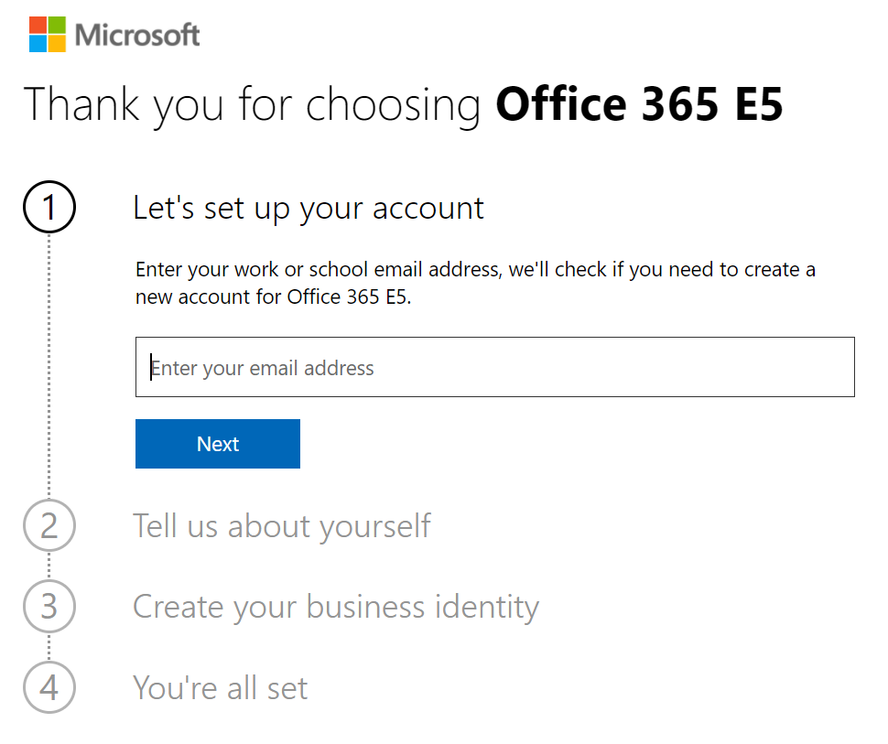

1. Fill-in information needed for registration. Note that phone number is required to verify your account

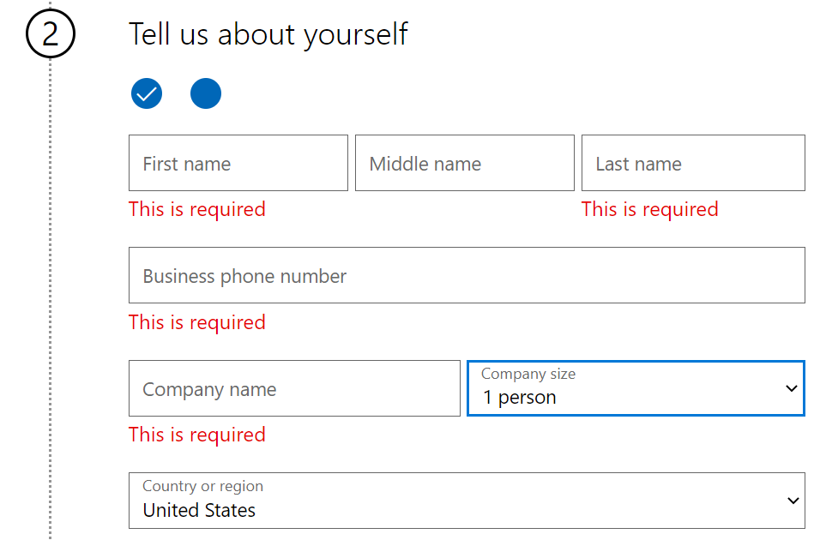

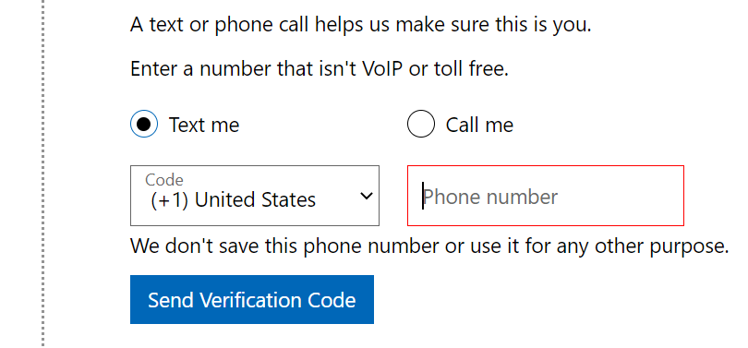

1. Type-in tenant name you want to have and check that same name is not already taken. If not the click Next

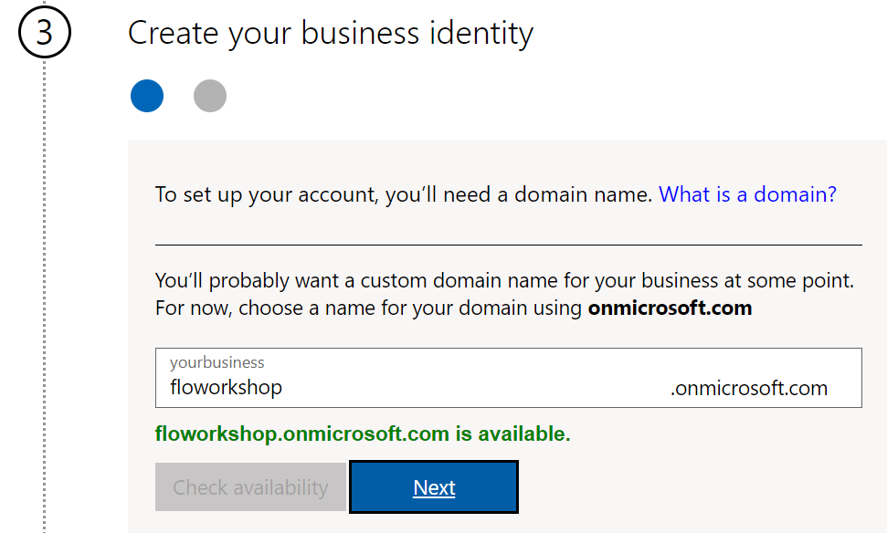

1. Create user ID and password for your account. This account will be Global Administrator of the tenant

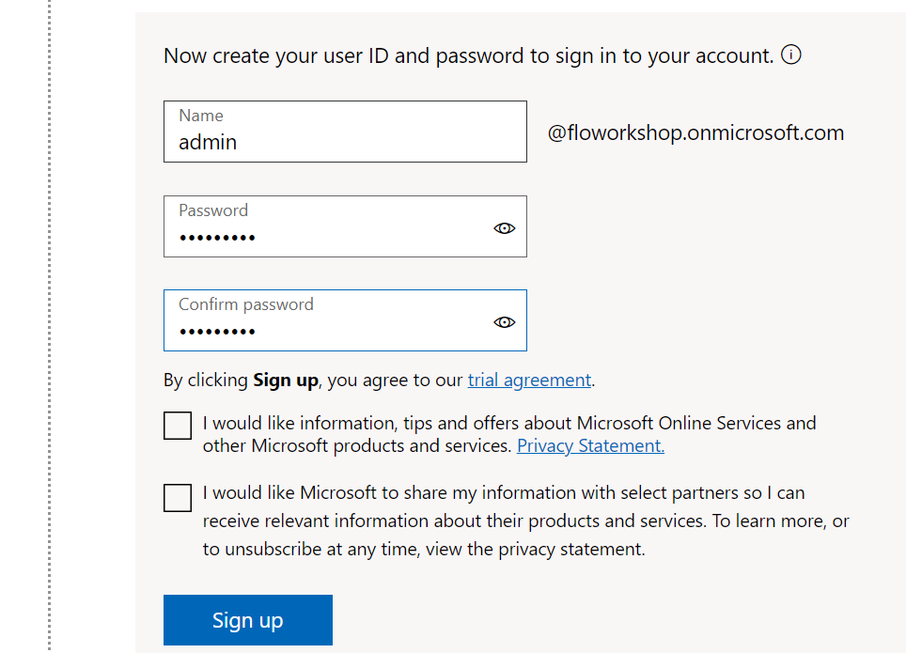

1. Tenant provisioning has started and it will take some time to all services are up and running

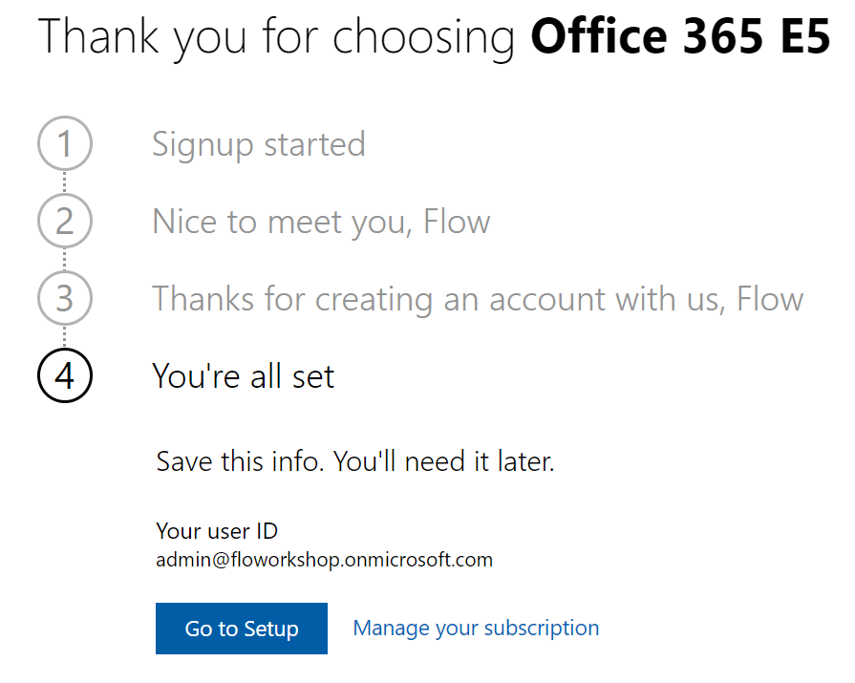

# Sign in to your existing / new test tenant or your organizations tenant

**NOTE!** If you create new trial tenant in previous step and try to provision demo content for the lab then you might need to wait some time for tenant to be fully provisioned.

1. Open <https://portal.office.com> preferably InPrivate/Incognito mode and login with your credentials
2. Click **SharePoint**

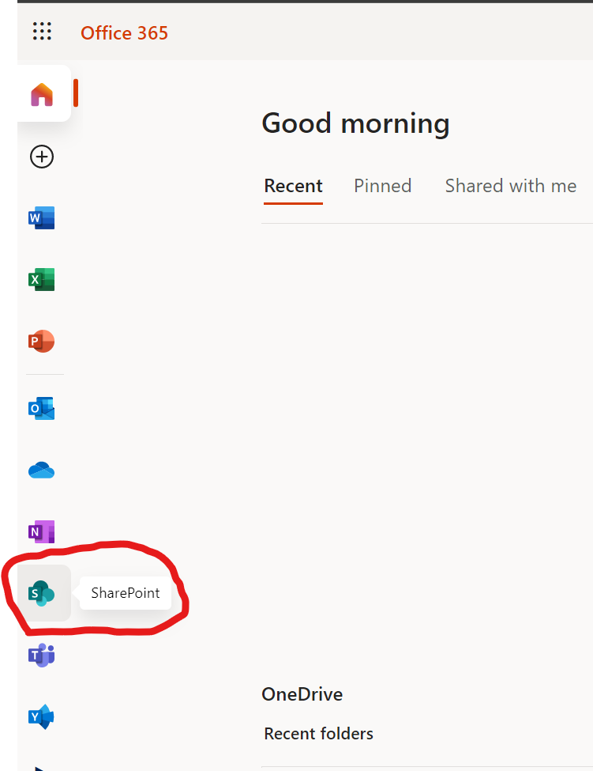

1. Click **Create site**

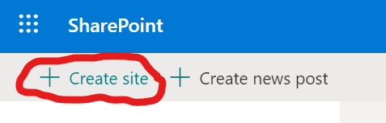

1. Select Team Site

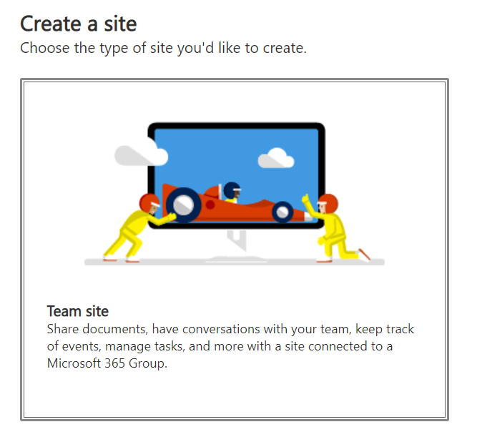

1. If you have own trial tenant then type-in site name **FlowTraining BUT** if you are using organization tenant where others are doing the labs as well then add your name or initials to site name like FlowTraining**PP** for example. This way we are able to differentiate site of each attendee. Click **Next** to start creating the site

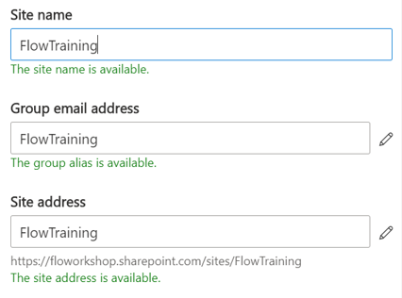

1. Click **Finish** and you will be redirect to your new site

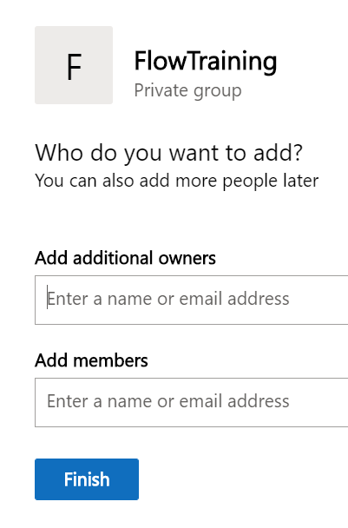

1. **Copy site address to notepad**

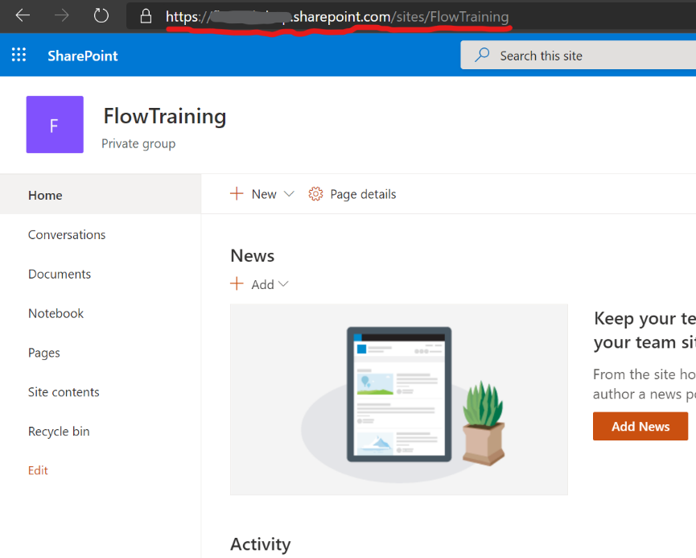

# 4. **IF** this is new trial environment, the Approval tables must be initialized. The easiest way to do this is to create a "dummy" approval flow.

1. Go to [flow.microsoft.com](https://flow.microsoft.com/) and click **My Flows**

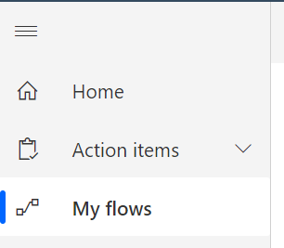

1. Select **+ New** > **Instant cloud flow**

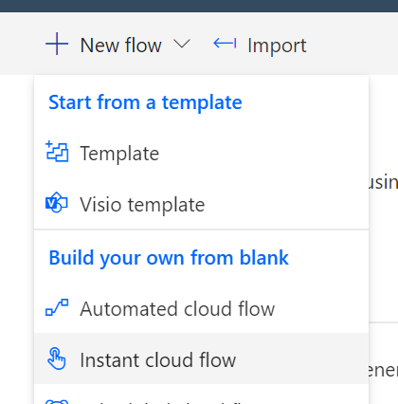

1. Pick **manually trigger a flow** as the trigger, enter **Dummy Approval Flow** as the name and click **Create**

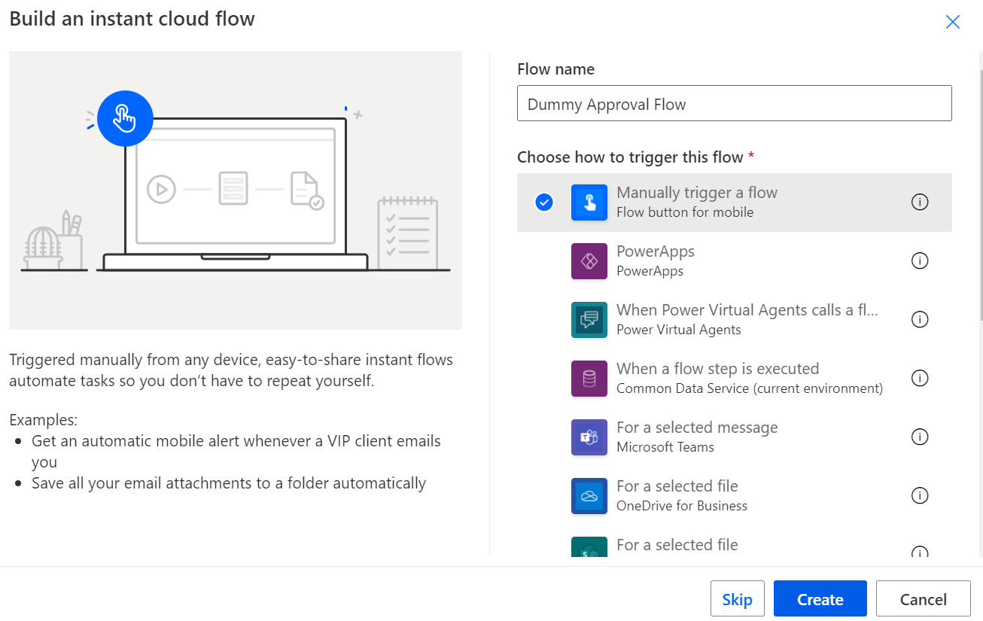

1. Select **+ New Step** to add an approval action to the flow, and then search for and select **Create an approval**.
2. Select a dummy title, and enter your email address under **Assigned To**.

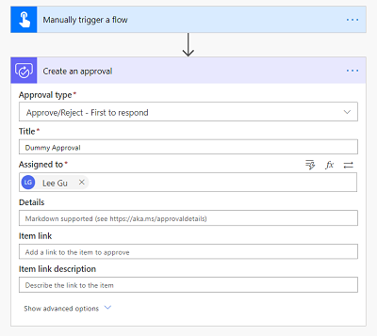

1. In the upper-right corner, select **Test**, select **Manually** and click **Test**

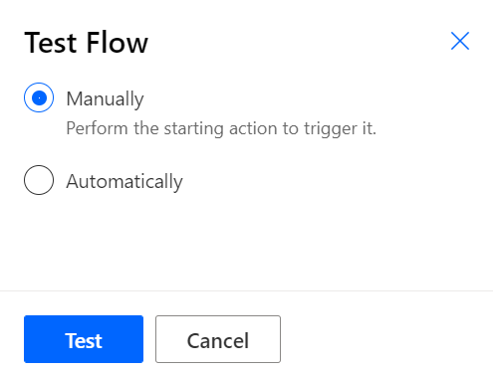

1. Select **Continue**

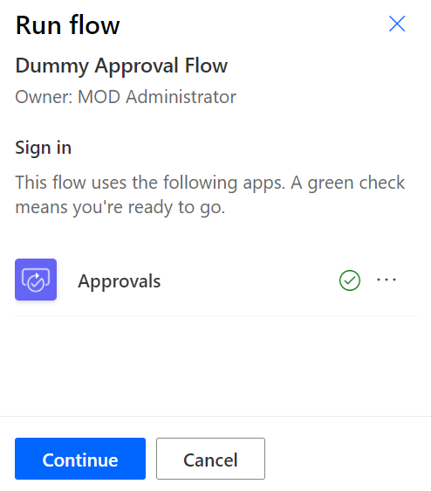

**Note,** This flow can take up to ten minutes to run initially. After it runs, you can delete the flow because it won't be needed anymore.

# Provision demo content for the labs

1. Open <https://flow.microsoft.com> and sign-in with your user ID
2. Select **My flows**

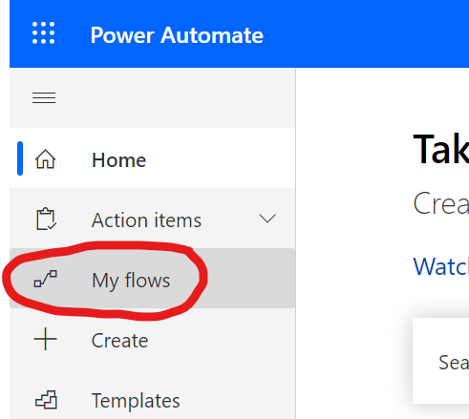

1. Click **Import**

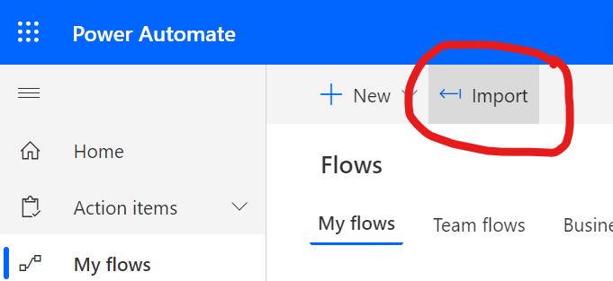

1. Click **Upload** and select **M0-FlowTrainingDemoContent.zip** file provided by the trainer

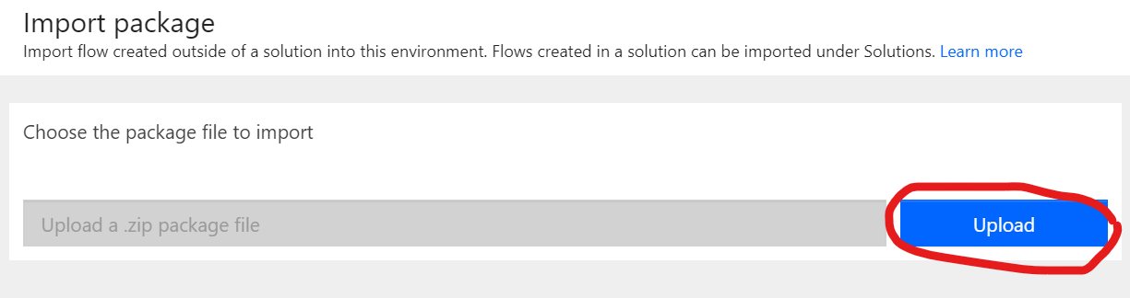

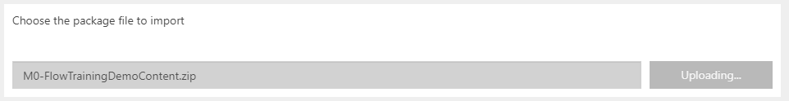

1. Click **Select during import** as below and configure SharePoint connection of the Flow

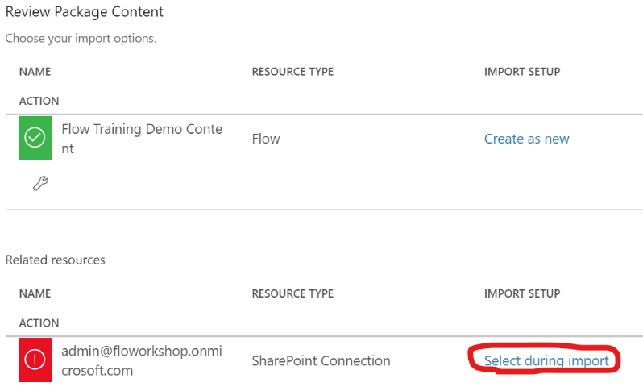

1. If there is existing SharePoint connection then select it from the list like below screenshot and then you can skip to step 14. If there is no existing connection then follow steps 7-13 for instructions how to create new connection

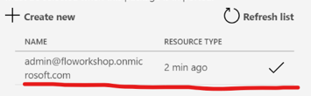

1. Click **+ Create new**

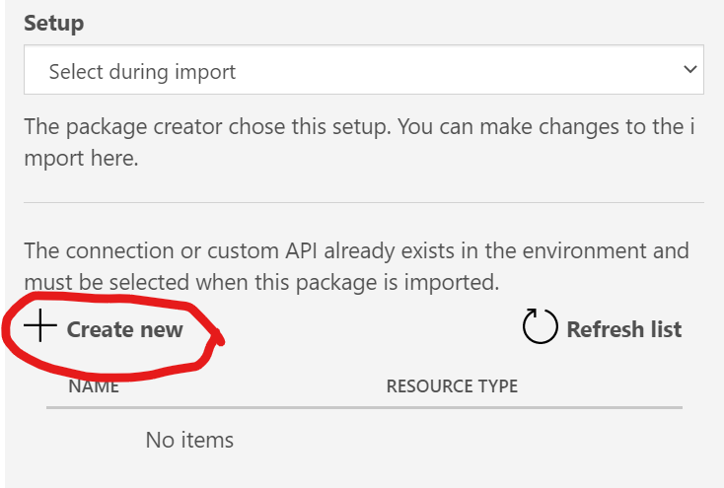

1. New connection configuration opens to new tab/window and from there click **New connection**

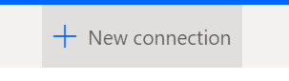

1. Create new SharePoint connection by clicking the + button

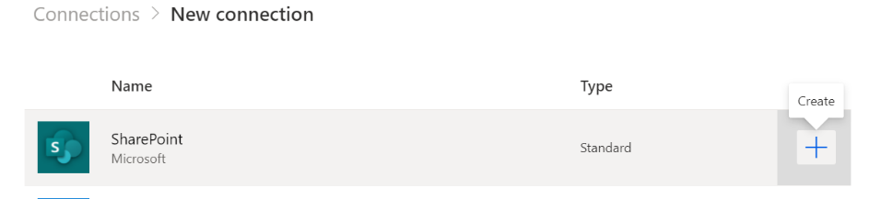

1. Click Create

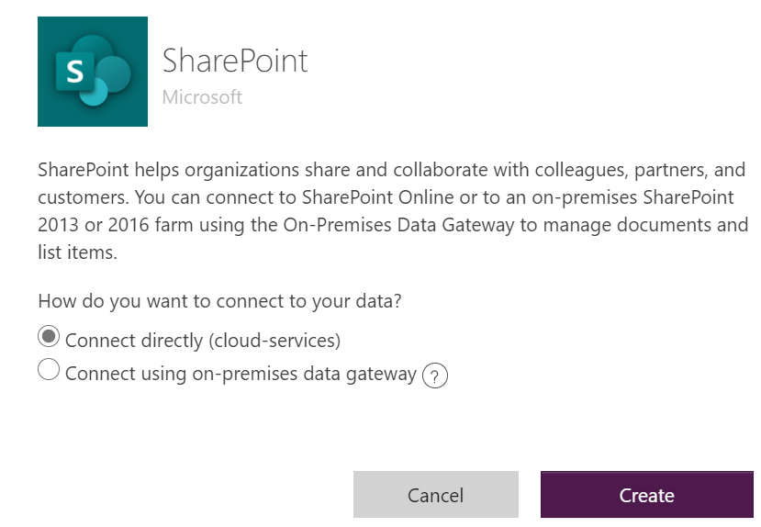

1. Login with your account

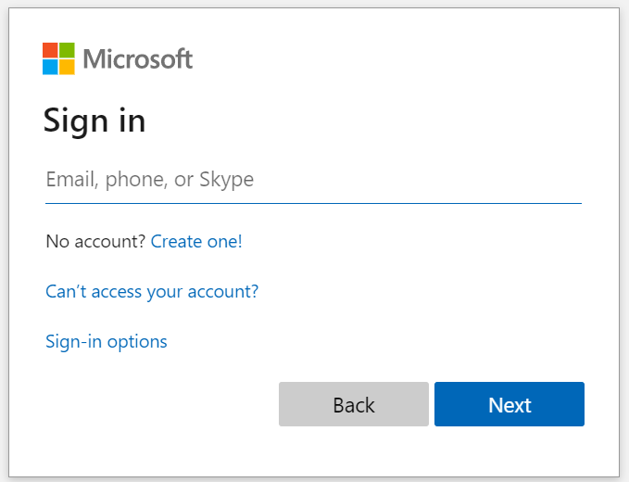

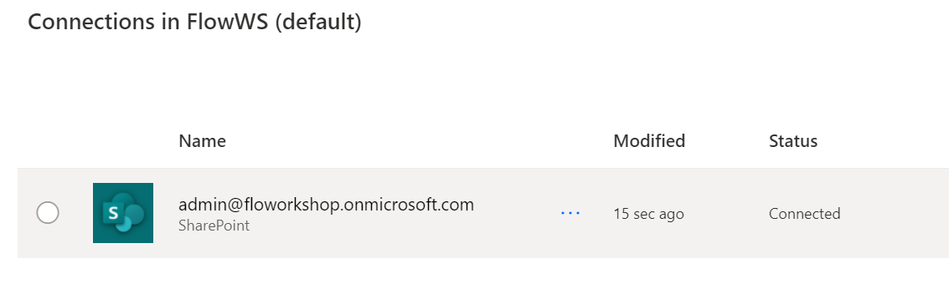

1. Move back to another tab/window where you are importing Flow
2. Refresh connection list and select the SharePoint connection you just created and click **Save**

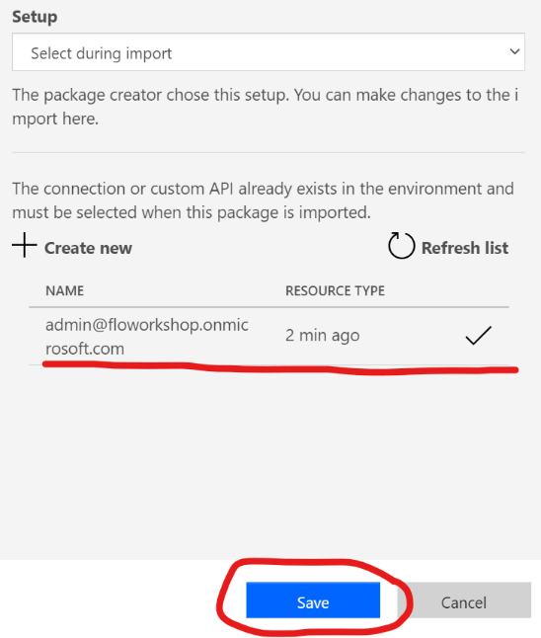

1. Click **Import**

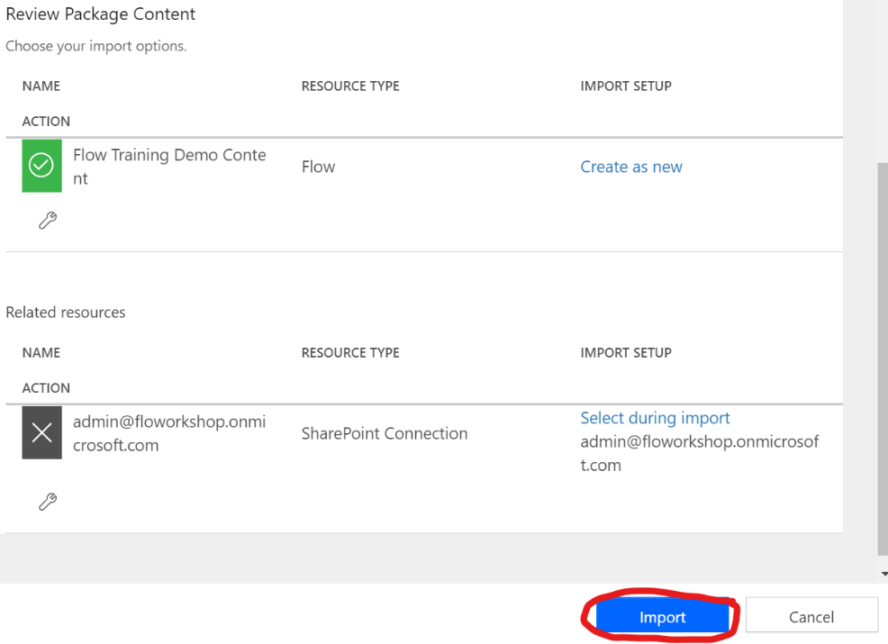

1. You should see the page like below when import is finished. Click **Open flow**

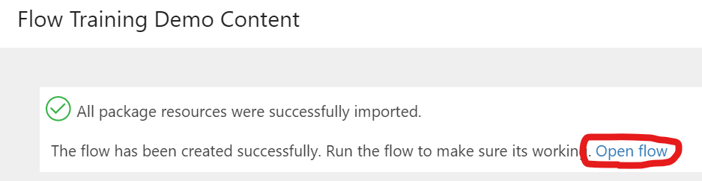

1. Open “**Initialize variable – SiteUrl CHANGE YOUR OWN**” and set the value of the variable to match the site’s URL you created in the Step 2. If you copied URL to clipboard / notepad then paste it to Value field

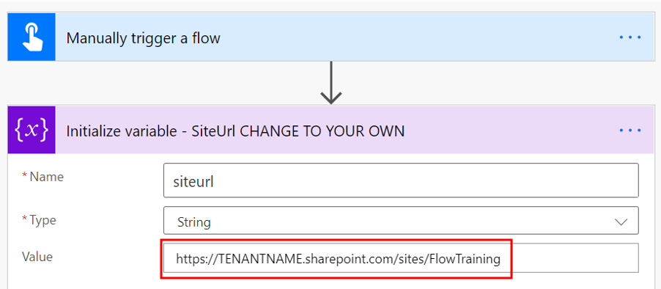

1. **Save** flow and click **Test**



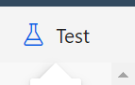

1. NOTE! If you receive warning that Flow is disabled then go to Flow details page and click “**Turn On**”

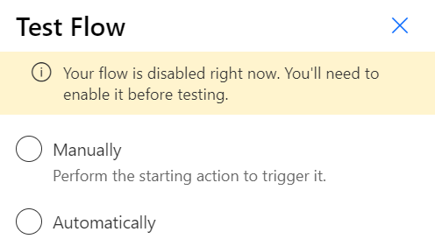

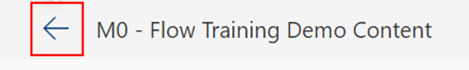

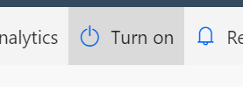

1. Click **Edit**

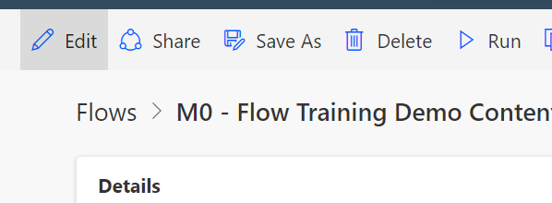

1. Click **Test,** select **Manually** and click **Continue** and **Run flow**

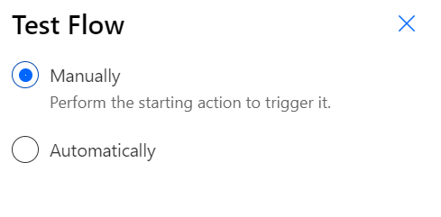

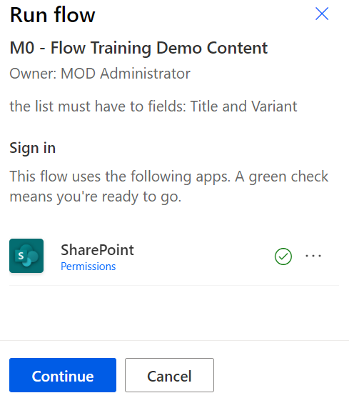

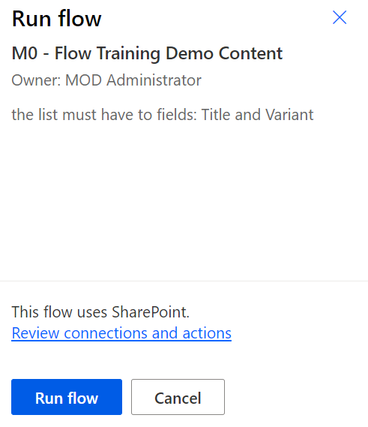

1. Flow will create SharePoint lists and libraries named **LargeList**, **CarsList, CopyDocuments** and **Forms Responses**. It will also populate demo content to CarsList, LargeList populate them with demo content.
2. Open SharePoint site’s **Site Content** page<https://TENANTNAME.sharepoint.com/sites/FlowTraining/_layouts/15/viewlsts.aspx> to monitor the progress of demo content creation and refresh page few times to see how many items list will have. Purpose of the flow is to create 6000 items to **LargeList** using batch commands. This is very fast operation to insert items to list but sometimes it might fail and not execute all batches correctly. Important thing for labs to work correctly is to have at over **5000** items in LargeList. If flow creates under 5000 items then just rerun the flow to create more items

